

Managing Emails

User Guide

Prepared by The Woodland Rangers

UGA MBT Capstone Project

April 28, 2018

The purpose of this document is to review the features, procedures and guidelines of maintaining and updating emails associated with Smithgall Woods. To access the email list:

1. 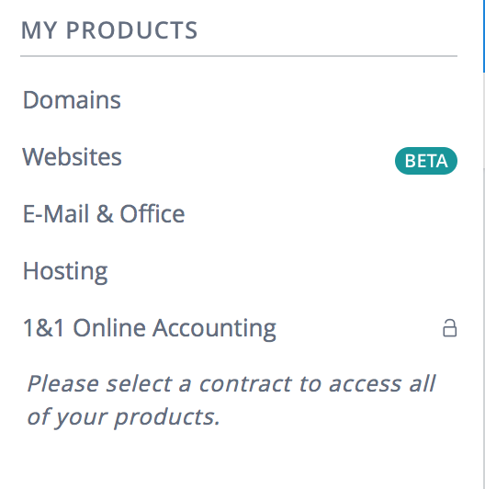Log in to <https://www.1and1.com/login?__lf=Static> with proper credentials.
2. On the left hand of the screen, click on “E-Mail & Office”
3. On the new screen, click “Select” below 1&1 Mail Basic.
4. 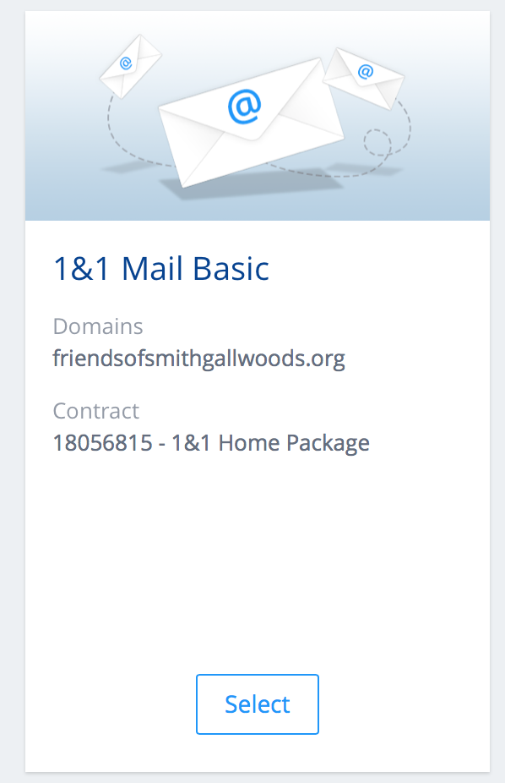This new page gives you an overview of the email services provided. With this package, you are allowed up to 1200 email addresses to be associated with Smithgall Woods.
5. To change a setting on an established email account, click on the gear icon to the right of the email.
6. The menu that drops down has two options that you will find useful. You can change the password or you can delete the account.

### **To Add an Email**

1. Complete steps 1 through 3 of the list above.
2. 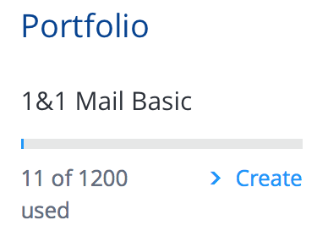On the right hand of the new screen, click on “Create” under the 1&1 Mail Basic Portfolio.
3. On the new screen, you can create the email to be associated with FriendsofSmithgallWoods.org. Be sure to select “friendsofsmithgallwoods.org” where it says select domain.
4. Provide the first and last names in the appropriate boxes.
5. Assign a password.
6. Click “Save” on the bottom of the screen.

### **Forwarding Emails to personal accounts**

There are situations where individuals check their personal email accounts a lot more frequently than they might check their Friends of Smithgall Woods email. There is a way for an emails sent to a Friends of Smithgall Woods email account can be automatically forwarded on to personal email accounts. Should the individual elect to have the Friends of Smithgall Woods email forwarded to their personal accounts, here is the procedure to do this:

1. Complete steps 1-3 from the first sections of this documentation.
2. Find the email address that you want to forward emails from. Click on the gear icon located on the same line of the email address.
3. A menu will pop up, click on “Settings”.
4. On the new page, click on “Forwarding Address”.
5. On the new page towards the top there is a box “+ Add Forwarding”, click on that box.
6. A new page will appear asking for the “Forwarding target”. This is where you will put in the personal email account like [johndoe@gmail.com](mailto:johndoe@gmail.com).
7. Once the personal email account has been entered, click “Continue”.
8. This saves the settings and now all emails to that particular Friends of Smithgall Woods email account will be forwarded to the individual’s email account.

### **Delete Forwarding Emails**

There will come a time where there is a change in administration, and someone will need to stop receiving Friends of Smithgall Woods emails in their personal email accounts. To stop the forwarding of Friends of Smithgall Woods emails to personal email addresses, follow the steps below.

*NOTE: The removal of personal email addresses will have no effect on the Friends of Smithgall Woods email accounts.*

1. Complete steps 1 through 4 from the “Forwarding Emails to Personal Accounts” section above.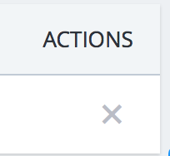
2. On the new page, you will see the list of personal email addresses receiving the particular Friends of Smithgall Woods email account. To delete one of the personal email addresses, click on the “X” below Actions towards the right of the page.
3. A confirmation box will appear. Click “Remove” to finalize the deletion of the personal email address.